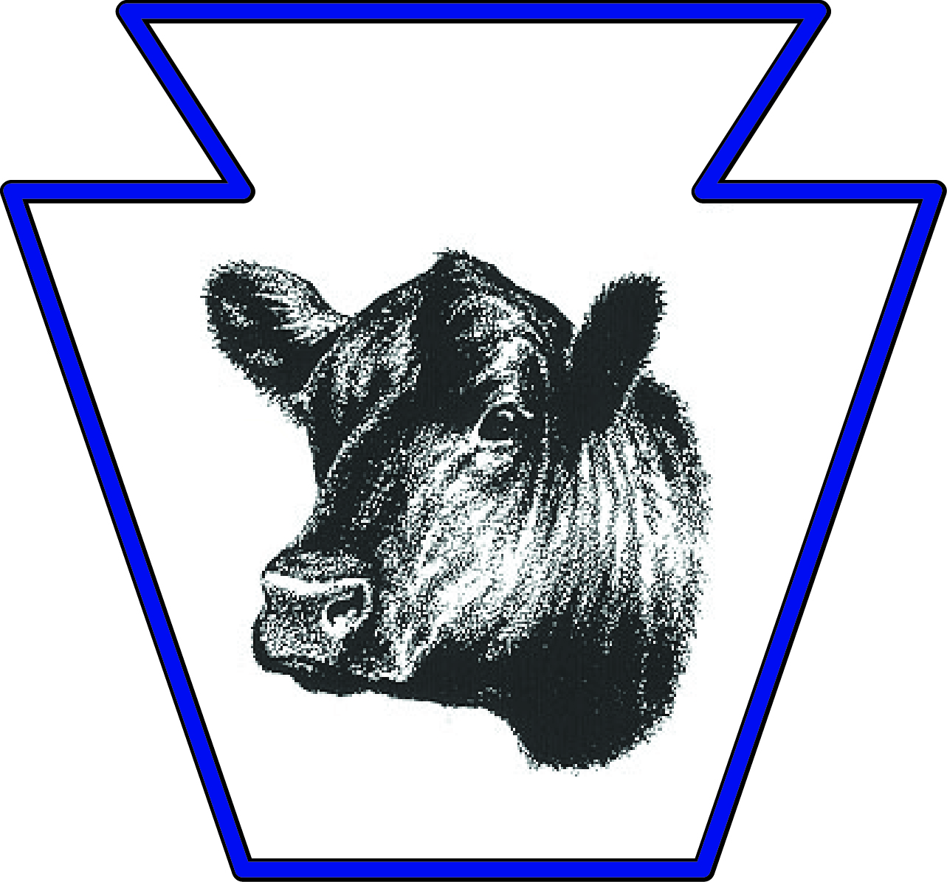
Pennsylvania Angus Association
2017 ANGUS ON PARADE SALE

August 1, 2017

Dear PA Angus Breeders,

On behalf of the Pennsylvania Angus Association, I would like to invite and encourage you to consign in the 2017 PA Angus on Parade Sale. It’s my pleasure to be working with the Pennsylvania Angus Association as the Sale Manager for this year’s sale. The decision was made by the Sale Committee to make changes to this year’s sale, in hopes of expanding the sale offering, engaging more buyers and maximizing the value for the consignors. With that said, the sale date and location have been changed to help achieve these goals. This year’s sale will be held on Saturday, September 23rd at the Pennsylvania Department of Agricultural Livestock Evaluation Center (Sale Arena) in Pennsylvania Furnace, PA. I feel this facility is ideal for the sale and should be very beneficial to both buyers and sellers.

I’m pleased to also announce, we have already secured consignments from ErReR Hill Farms that will liquidate the remainder of their registered herd. Bob Hay and the Riggs Family have graciously committed app. 25 head of Spring Pairs, Fall Bred cows and Spring Bred heifers along with their remaining semen and embryo inventories. This consignment will write the final chapter of their storied operation.

I will be including the professional services of Mr. Dan Wells, of Ohio, to assist me with the organization and preparation of this year’s sale & catalog. Dan will be collecting the information on your consignments. Here is his contact information for your reference: Cell: 740-505-3843 or email: dpwells@horizonview.net. To keep us on schedule, the deadline for consignment information will be August 25th.

Please let me know if you have any questions. I look forward to working with you to make the 2017 PA Angus on Parade Sale a huge success!

Sincerely,
Dave Mullins
Dave Mullins, Auctioneer
Cell: 317-503-2798
dwm12278@gmail.com

